**PARENT MODEL FIELD IN CHILD MODEL SERIALIZER**

REF:

<https://stackoverflow.com/questions/27851138/how-can-i-get-the-parent-object-in-django-rest-framework-serializer>

IN ORDER TO ACHIEVE THIS GOAL, WE HAVE TO ADD SOME CONFIGURATION INSIDE SERIALIZER CLASS:

1. ADDING NEW FIELD INSIDE MODEL SERIALIZER CLASS TO LINK IT TO PARENT’S FIELD

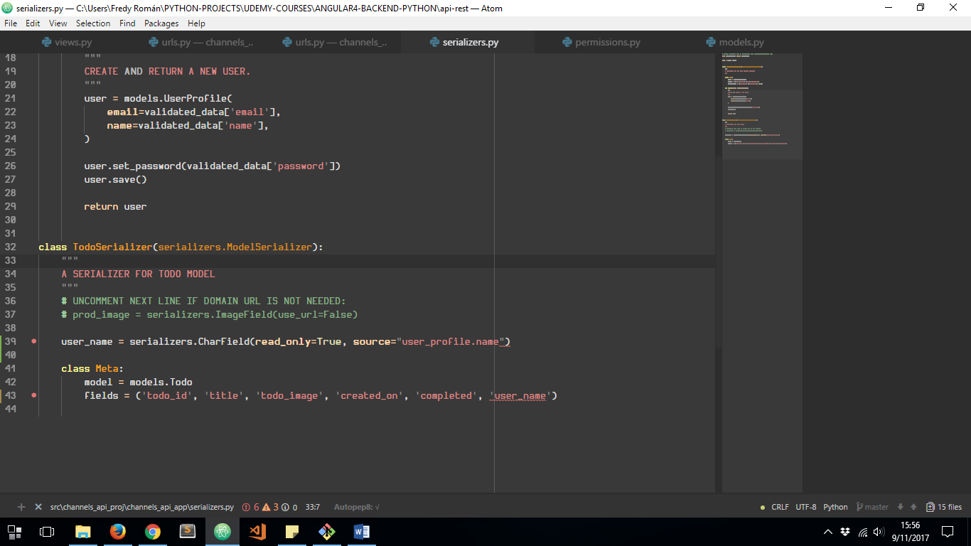

1. LET’S SEE HOW IT TAKES EFFECT:

